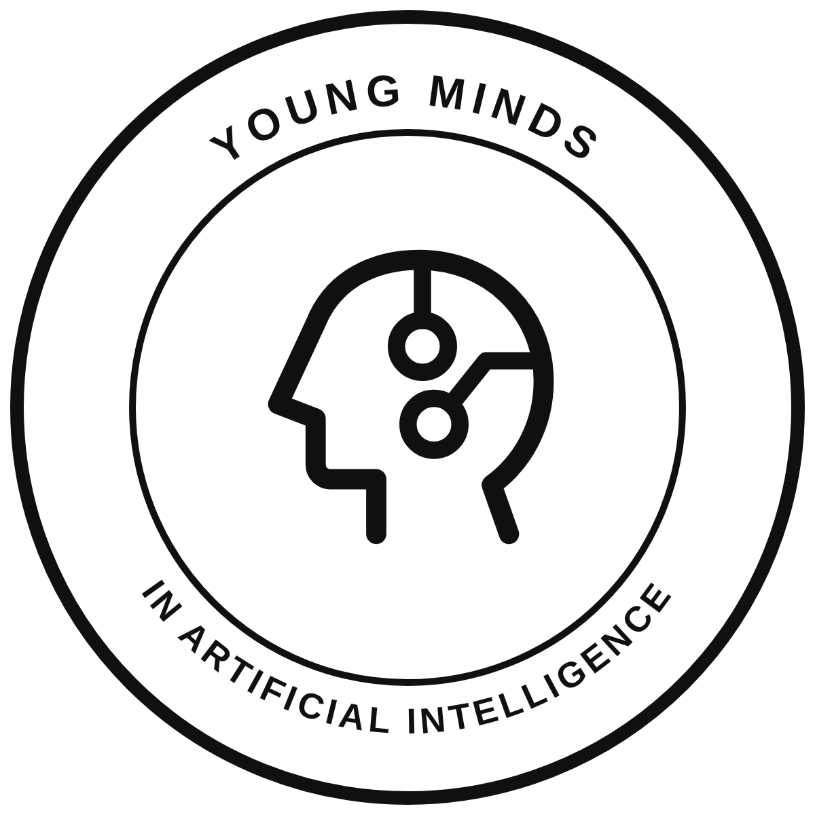

YMAI International Founding Charter
Founding draft for consultation - Version 1.0

1 Name and status
1.1 The name of the initiative is Young Minds in Artificial Intelligence, abbreviated YMAI and pronounced why-my. YMAI International coordinates the shared network. Country chapters organise its work nationally, and YMAI Student Associations bring that work into schools and universities.
1.2 YMAI begins as an independent, student-led educational initiative. Neither this charter nor chapter recognition creates a legal entity, charitable registration, tax exemption, institutional endorsement, or authority to enter contracts on another person's behalf.
1.3 YMAI is not yet legally registered. This document is a proposed founding charter, not adopted incorporation articles. If YMAI incorporates, its lawful governing documents and statutory duties take precedence. Material differences must be explained to members and reflected in a revised charter.

2 Purpose and principles
2.1 YMAI exists to support students interested in the development of artificial intelligence and to improve public understanding of its capabilities, limitations, and effects on society.
2.2 Its educational work may include peer learning, workshops, practical projects, accessible publications, and public discussion. Activities should connect technical understanding with responsible practice and make room for both beginners and experienced students.
2.3 YMAI will promote curiosity, intellectual honesty, inclusion, respect, and public benefit. It will credit other people's work, respect privacy and intellectual property, disclose relevant conflicts, and avoid presenting speculation or promotional claims as established fact.
2.4 YMAI is independent of political parties and of any school, competition, company, or public body unless an explicit relationship has been agreed and accurately described. Personal achievements of members do not imply institutional endorsement.

3 Membership and participation
3.1 The main membership is students in high school or university, or the local educational equivalent. Country chapters must publish suitable eligibility rules, taking account of local education systems, law, and safeguarding needs. Educators, mentors, alumni, and other supporters may contribute in clearly identified supporting roles.
3.2 An expression of interest is not automatic admission, a programme place, an appointment, or chapter recognition. Admission and participation arrangements must be explained before a student commits. No fee or fundraising obligation may be introduced without advance disclosure and proper approval.
3.3 Members may ask questions, propose activities, receive relevant decisions, raise concerns without retaliation, and leave voluntarily. They must respect this charter, reasonable conduct rules, local requirements, and the rules of their institution.
3.4 Participation may be restricted where necessary for safety or lawful operation. Apart from urgent protective action, the person affected should receive the reasons, an opportunity to respond, and access to review by someone without a relevant conflict of interest.

4 Founding leadership and transition
4.1 Matthew Williams is the founder and will serve as Founding Chair during the Founding Period. This preserves responsibility and continuity while the initiative recruits its first team, develops programmes, and establishes its governance.
4.2 The Founding Period continues until twelve months after Matthew first enrols in a university degree programme. The date of enrolment and the resulting transition timetable must be recorded. The founder may choose an earlier handover by a written decision; no ordinary vote may require an earlier handover merely because new members have joined.
4.3 If university entry is deferred, the proposed timetable must be reviewed annually with the board and published. Any extension beyond twelve months after actual enrolment requires a published reason and approval by two-thirds of the board, including a majority of members other than the founder. An extension may not exceed one further year.
4.4 During the Founding Period, the Founding Chair directs strategy and ordinary operations and retains approval of changes to the name, core mission, charter, recognition of country chapters, and appointment or removal of national coordinators. These powers remain subject to law, financial controls, conflicts procedures, and the safeguards in this charter.
4.5 Founding authority does not permit interference with a safeguarding report, independent complaint, lawful investigation, or a director's statutory duty. It does not authorise personal use of organisational funds or unilateral approval of a benefit to the founder or a connected person.
4.6 Before a board is appointed, the founder may undertake preparatory work and recruit a team. This does not permit activities involving minors without appropriate safeguards, or fundraising and contracts without lawful capacity and agreed controls. Proposed positions must not be presented as filled.
4.7 If the founder resigns, dies, is unable to act for three months, or must be removed to meet a legal duty following independent review of serious misconduct, an interim chair is chosen by the remaining board members. No person may use this continuity provision to obstruct necessary protective action.

5 International board and decisions
5.1 The proposed International Board has between three and seven voting members. Students must form a majority. It should include the chair, a person responsible for administration and records, and a person responsible for financial oversight. At least one suitable independent adult adviser must be available before activities involving minors begin; an advisory title alone does not confer a vote.
5.2 Initial appointments are made by the Founding Chair after considering ability, integrity, student representation, and relevant experience. Appointments, responsibilities, terms, and conflicts must be recorded and published. Legal offices may be held only by people eligible to hold them.
5.3 After the Founding Period, recognised country chapters elect the board through a published process giving each active chapter one equal vote. With only one chapter, its admitted student members elect the student representatives directly. An independent returning officer should oversee the election. The board elects its chair; the founder may stand without a permanent veto or automatic majority.
5.4 Ordinary board terms are two years, with one consecutive re-election. Staggered initial terms may preserve continuity. Temporary vacancies may be filled until the next election. Student eligibility is assessed at appointment; a member who finishes their studies may complete that term, subject to the continuing student-majority requirement.
5.5 The board should meet at least quarterly. A quorum is a majority of filled voting seats, never fewer than two. Ordinary decisions require a majority of votes cast. The chair has no additional casting vote. A tie leaves the proposal unapproved. Reserved founding decisions also require the founder's approval during the Founding Period.
5.6 Relevant interests must be declared. A conflicted member must not vote on the matter or count towards its quorum. If too few unconflicted members remain, the decision must wait or be referred for independent advice and a properly constituted decision. Minutes must record significant decisions, reasons, approvals, and dissent.

6 Country chapters
6.1 A country chapter coordinates YMAI nationally, supports local associations, adapts programmes, and maintains appropriate local records. YMAI Jamaica is the founding country chapter. Additional chapters require written recognition from International before using the YMAI identity publicly.
6.2 A proposed chapter must identify at least three organisers, its student leadership, a suitable adult or institutional adviser, local eligibility and safeguarding arrangements, and a realistic first activity. Its recognition agreement must identify responsibility for legal compliance, finances, data, reporting, and the limits of its authority.
6.3 Recognition is an affiliation, not incorporation or authority to represent International in a contract. A chapter must not raise funds, open an account, promise a tax benefit, or grant a further legal affiliation without the required written approval and lawful arrangements.
6.4 Each chapter should provide at least an annual activity and financial update. Recognition may be suspended for a material breach or urgent safety concern. International must give written reasons and a fair review route. Local legal duties and protective action continue during any dispute.

7 School and university associations
7.1 A YMAI Student Association is an institution-based group affiliated through its country chapter. Where no country chapter exists, International may supervise a provisional association until a suitable national structure is available.
7.2 Recognition normally requires at least three interested students, two named student organisers, a staff adviser or other institution-approved adult, institutional permission, and a simple activity plan. The institution retains authority over its premises, students, and rules.
7.3 Student organisers should be chosen by the association's members for one academic year, with a documented handover. The first organising team may serve until the first practical election. Associations should welcome new students and avoid making continuity depend on one person.
7.4 Associations may not imply that their institution endorses YMAI without permission. They may not independently sign contracts or fundraise under the YMAI name. Recognition and use of the identity are subject to the same conduct, safety, and reporting standards as the wider network.

8 Safety and responsible AI practice
8.1 Before an activity involving minors begins, the responsible organisers must confirm named adult supervision, local consent requirements, a risk assessment proportionate to the activity, and a suitable reporting route. School and legal requirements take precedence over convenience.
8.2 Harassment, discrimination, exploitation, bullying, and sexual misconduct are unacceptable. Organisers must use appropriate venues and channels and avoid unsupervised private one-to-one contact between adults and minors. Images and recordings require appropriate permission.
8.3 Concerns must be received respectfully, handled only by people who need the information, and referred promptly to the relevant institution or authority when necessary. Absolute confidentiality cannot be promised. A complaint about the founder or another leader must have a route outside that person's control.
8.4 AI projects must use data lawfully and responsibly, respect intellectual property, test limitations, and disclose meaningful use of AI. Personal or sensitive student data must not be uploaded to tools without appropriate authority. YMAI activities must not facilitate harm, deception, or academic dishonesty.

9 Finances and organisational assets
9.1 Money and other resources must serve YMAI's educational purposes. No net income or organisational asset may be distributed for private benefit. Properly authorised reimbursement or reasonable payment for real services must be documented, lawful, and approved without a conflict of interest.
9.2 Before accepting funds, the responsible body must establish a lawful recipient, an account and record-keeping process, a budget, and at least two eligible people with appropriate oversight. No individual may approve their own reimbursement or both authorise and reconcile the same payment.
9.3 Donations and sponsorship must be accurately described. YMAI must not claim charitable registration, tax deductibility, or restricted use of money unless those claims are valid. Donor restrictions, conditions, and conflicts must be recorded and honoured.
9.4 Custodians must keep organisational funds, records, domains, brand assets, and account access separate from personal use and arrange documented handover. Contracts, ownership transfers, and registration require appropriate legal authority; this charter alone does not execute them.

10 Accountability and changes
10.1 The board must maintain current leadership and chapter records, a decisions register, and suitable financial records. It should publish an annual account of activities and finances proportionate to the initiative's size, without exposing private student information.
10.2 Personal data should be limited to what is needed, used for stated purposes, protected with appropriate access controls, and reviewed for retention. Members must have a way to request corrections or raise privacy concerns.
10.3 An amendment requires at least fourteen days' notice, a clear explanation, and approval by two-thirds of the filled board seats. During the Founding Period it also requires the founder's approval. After that period, a change to the core mission or chapter voting rights also requires two-thirds of active country chapters voting on the proposal.
10.4 Dissolution requires the same notice and a three-quarters board majority, together with any approval required by law. Liabilities must be settled and lawful donor restrictions honoured. Remaining organisational assets must be transferred to a suitable registered educational or charitable body with similar purposes, not to members or the founder.
10.5 This draft becomes an internal charter only when formally adopted in a written decision identifying the adopting body, date, and approved version. The adoption record and any material amendments must be published. Until then, the document remains a proposal for consultation.

